ATTENTION STUDENT: If you are found to have plagiarized any part of your PsychSim assignment, you will receive a 0 for the assignment and may be formally reported to KPU. If you wish to quote the source provided or any other webpage, you MUST cite the source using APA formatting. To avoid plagiarism, write all answers in your own words.

For more information on plagiarism and cheating, please visit https://libguides.kpu.ca/academicintegrity/plagiarism to study the videos and tutorials available.
​
KPU's policy on academic integrity is found at https://www.kpu.ca/student-rights-responsibilities/academic-integrity

Name this file using the following format:
LastnameFirstname_Section_AssignmentName
For example: SmithJohn_A54_AuditorySystem

PsychSim Online: Brain and Behaviour
Name: _______________________ Student ID: _________________
Course/Section: _______________ Instructor: __________________

Watch this video to answer the following questions:
https://www.youtube.com/watch?v=vHrmiy4W9C0

Fill in the blanks:
- The _________ Nervous System is the “command center” and contains the brain and spinal cord
The _________ Nervous System “reports” to the brain and spinal cord, and contains sensory and motor neurons
________ Cells are cells that surround, insulate, and support cerebral neurons

- In your own words, describe what behavioural differences occurred after Phineas Gage’s accident. What does this tell us about our behaviour as it relates to the brain and its structures?

- List the structures of the “old brain” based on the picture below and state the functions

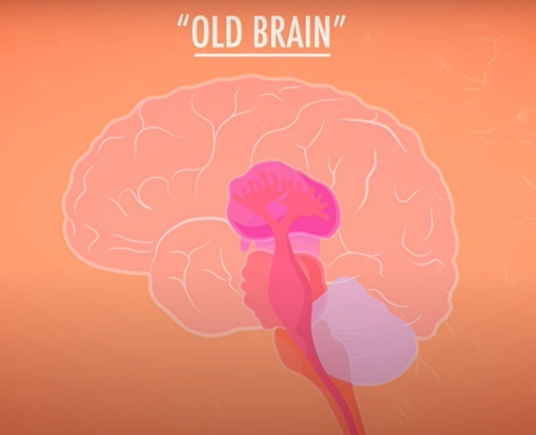
A
D
E
B
C
F

 | Structure | Function
A
B
C
D
E
F

- List the structures of the limbic system based on the picture below and state the functions.
A
B
D
C

 | Structure | Function
A
B
C
D

- List the lobes of the cerebral cortex based on the picture below and state their functions.
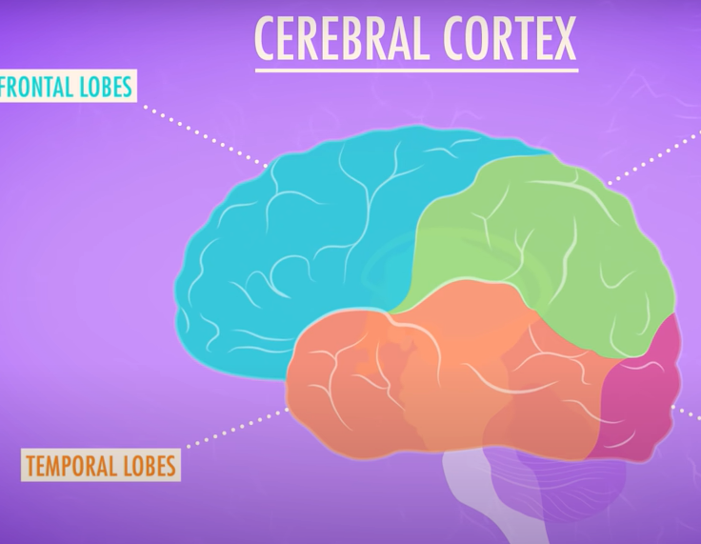
A
D
C
B

 | Lobe | Function
A
B
C
D

- What are the functional differences between the old brain, the limbic system, and the new structures of the brain? What is an example of an animal species with only the lower functions of the old brain?

